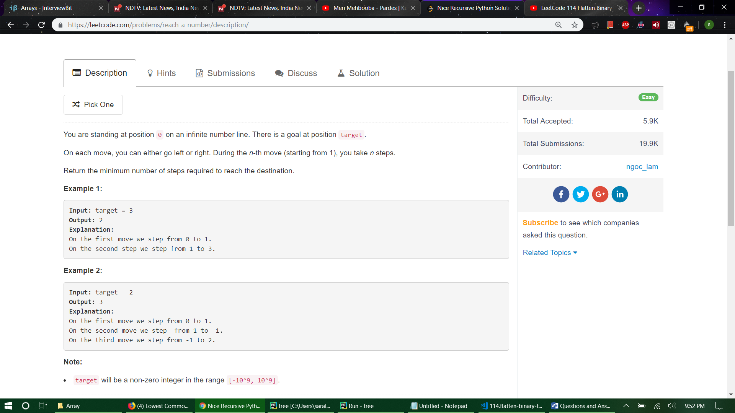

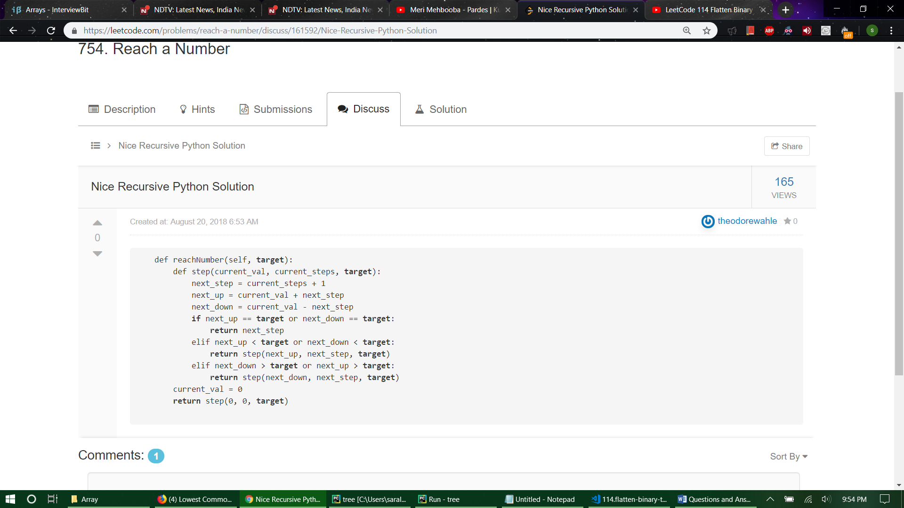

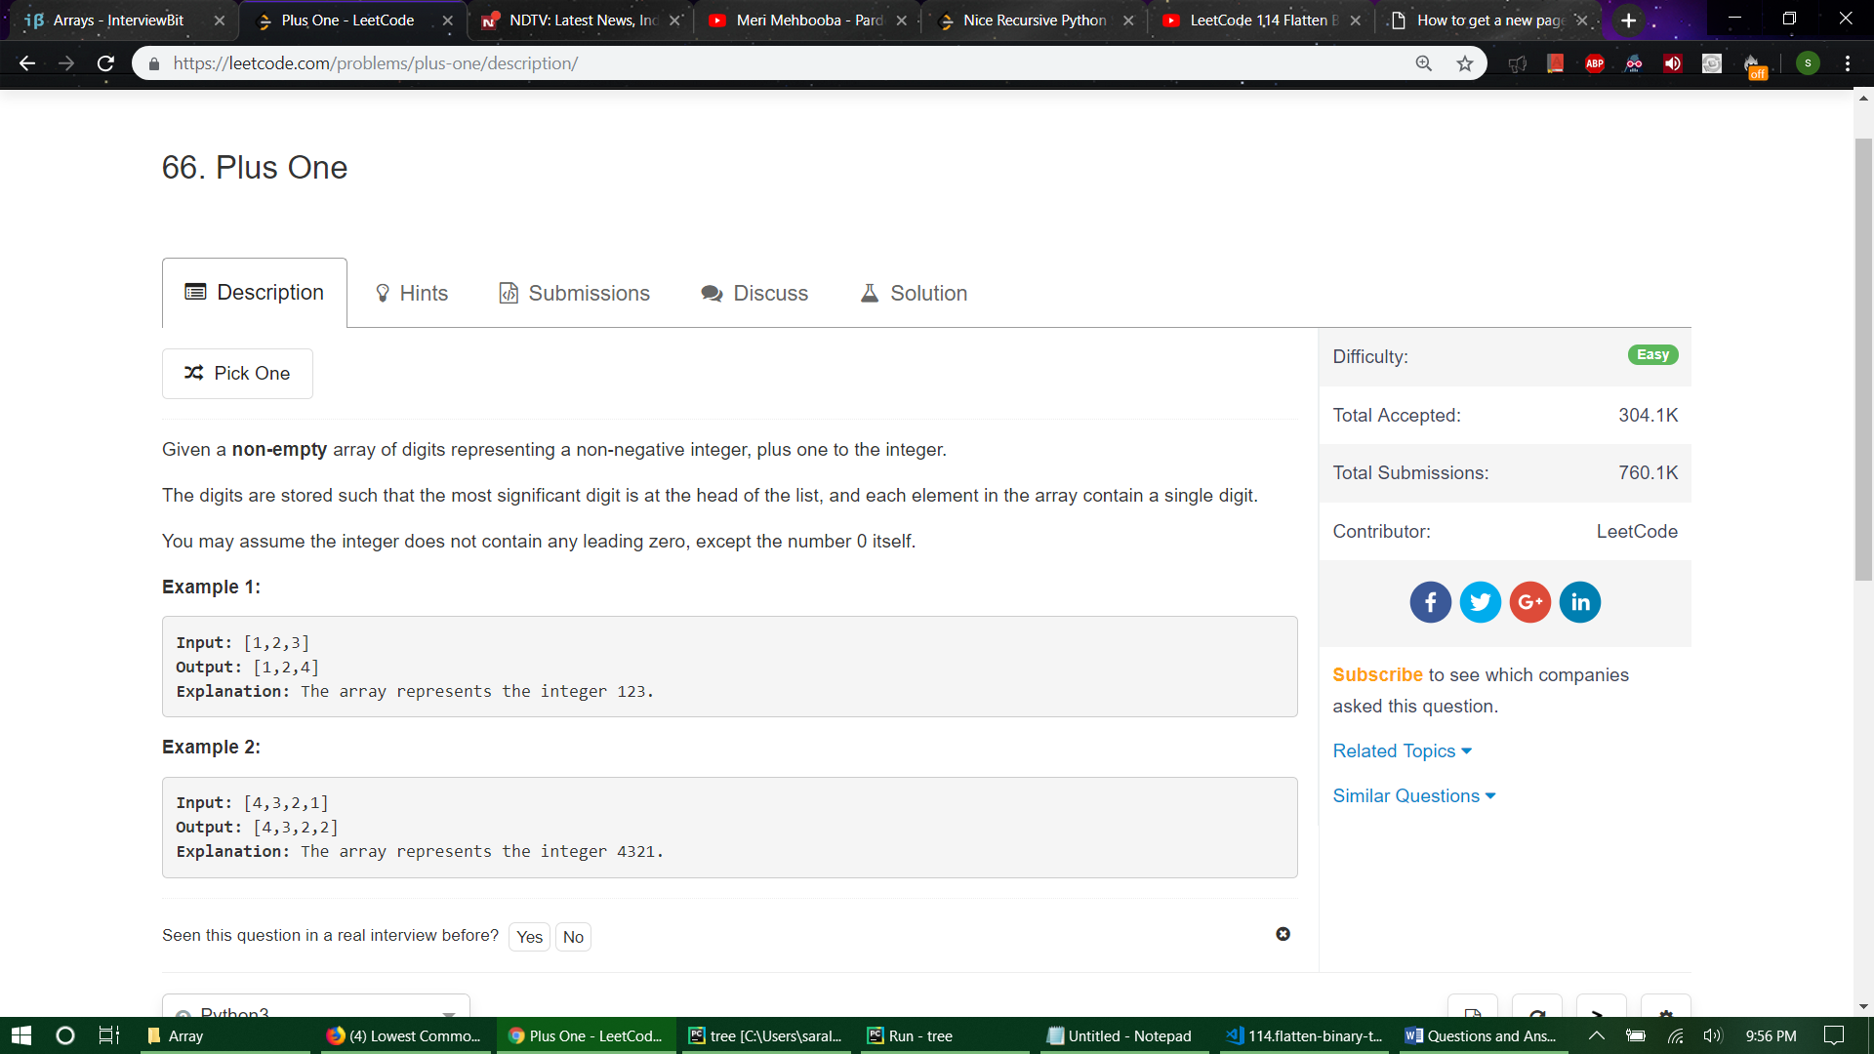

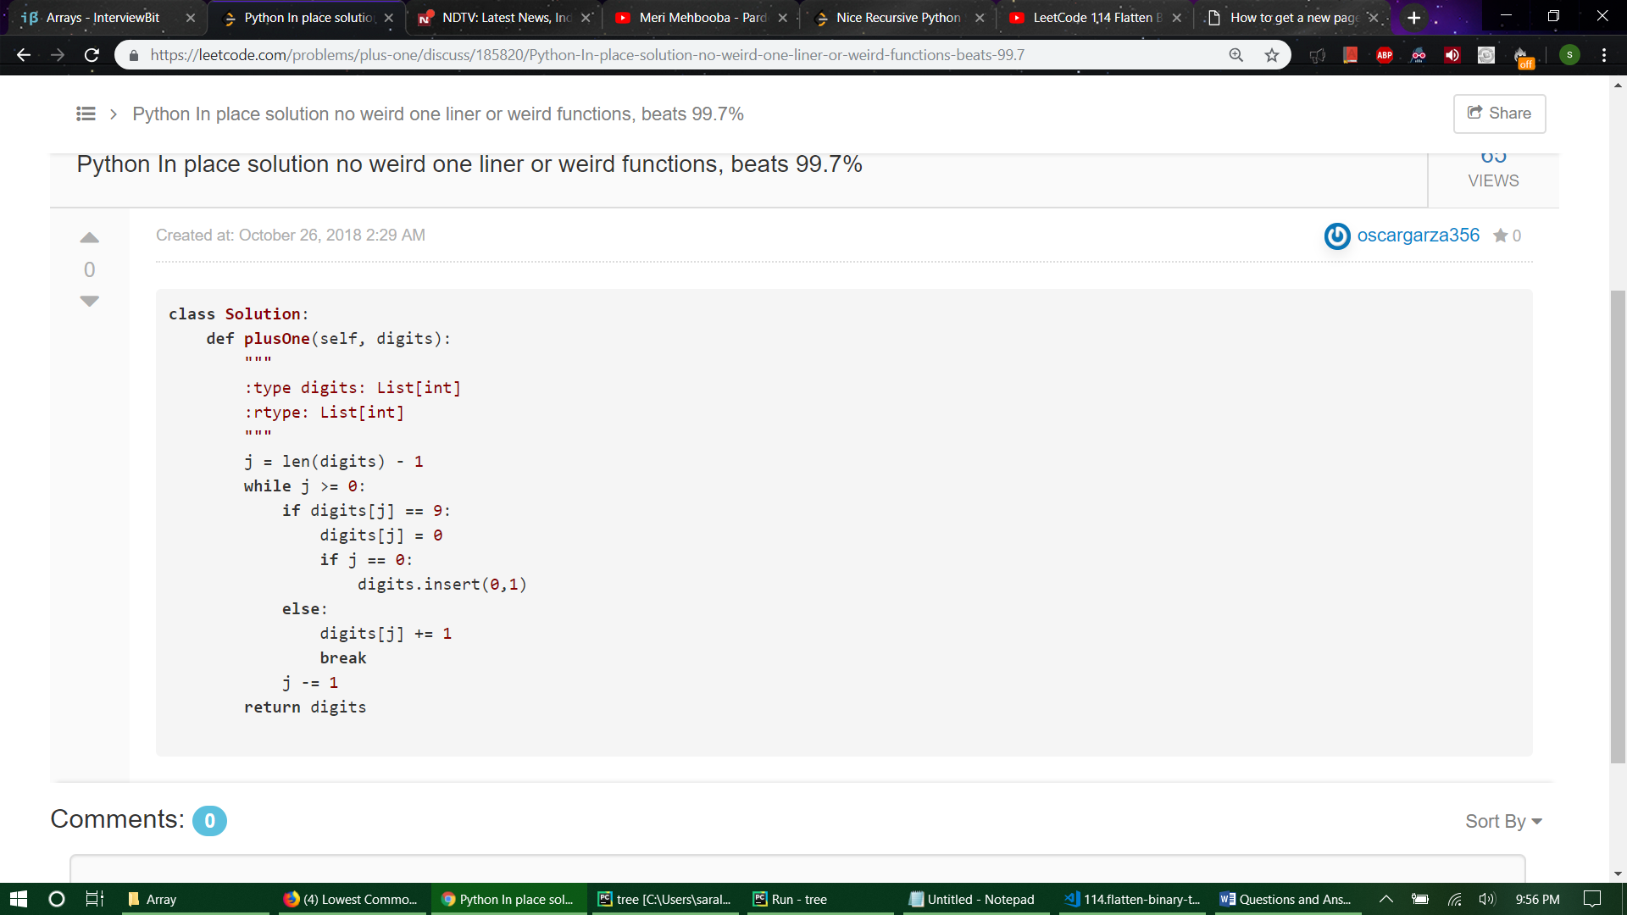

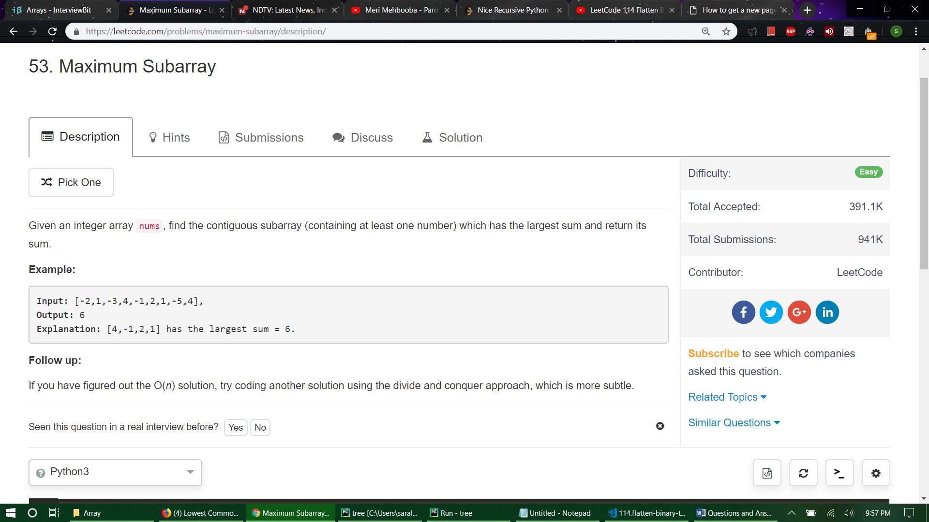

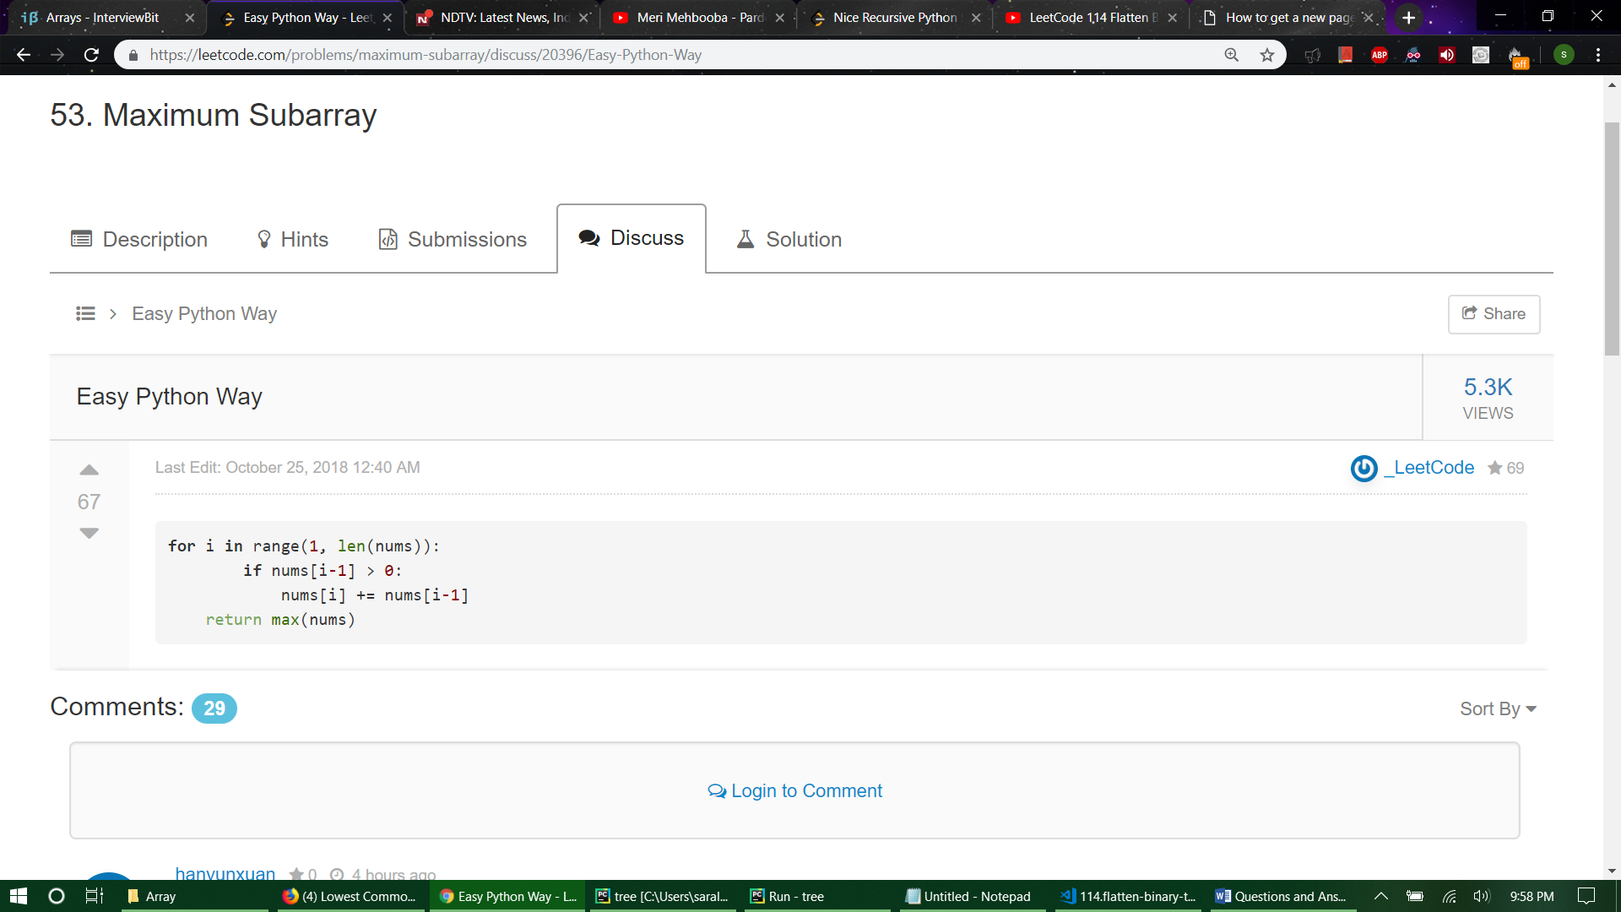

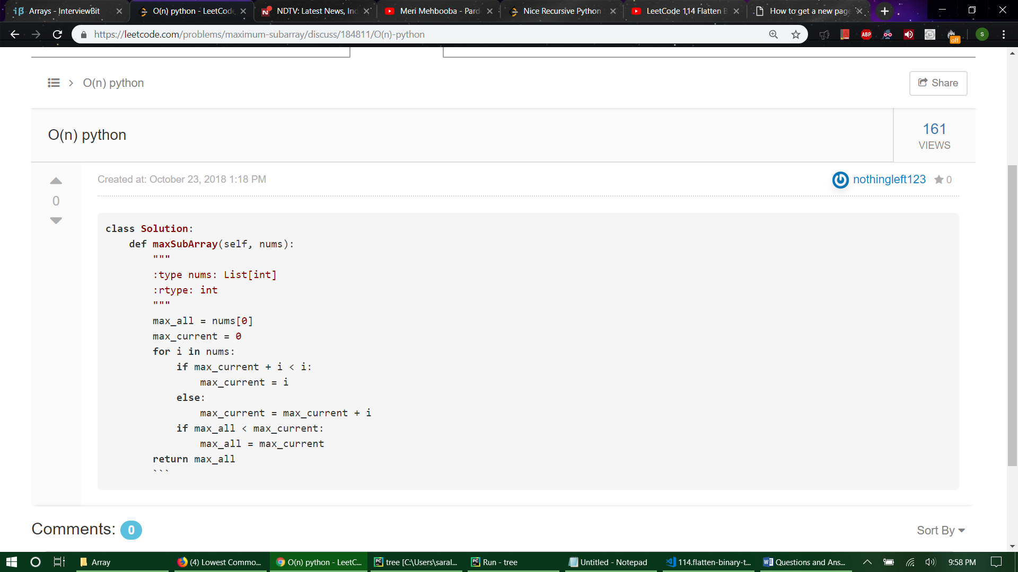

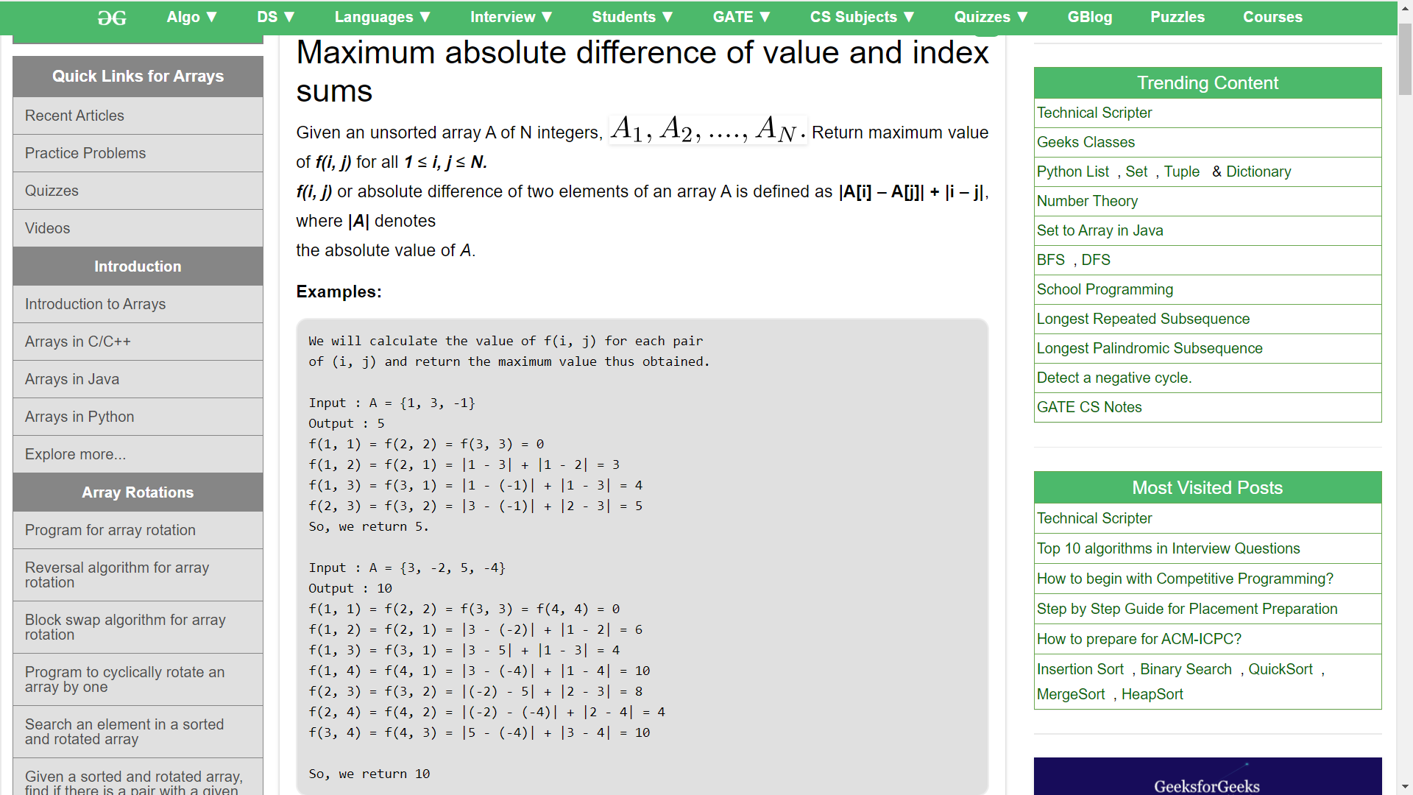

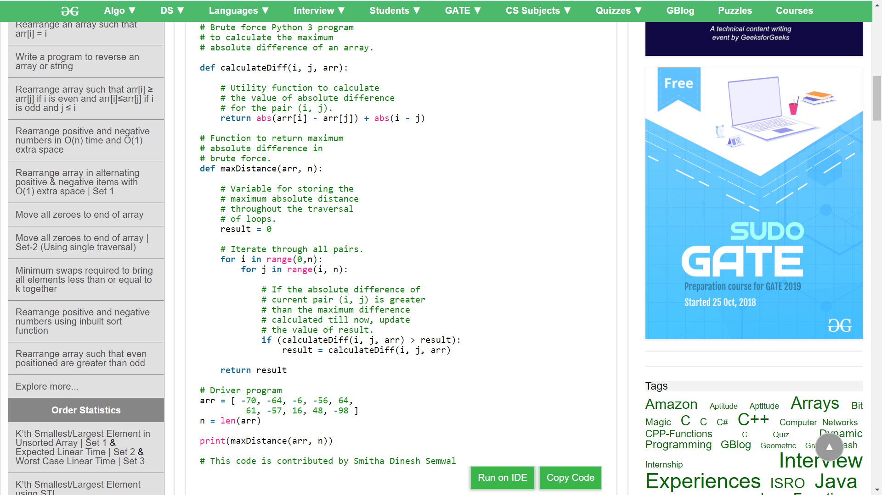

**class Solution:**

**def maxArr(self, A):**

**lista=A**

**AminusI = lista[:]**

**AplusI = lista[:]**

**# print(AminusI)**

**for i in range(len(lista)):**

**# print(a[i],i+1)**

**# print(a[i]- (i + 1))**

**AminusI[i] = (AminusI[i] - (i + 1))**

**AplusI[i] = (AplusI[i] + (i + 1))**

**# print(AminusI)**

**# print(AplusI)**

**apimax = max(AplusI)**

**apimin = min(AplusI)**

**amimax = max(AminusI)**

**amimin = min(AminusI)**

**valmax = max(apimax - apimin, amimax - amimin)**

**return(valmax)**

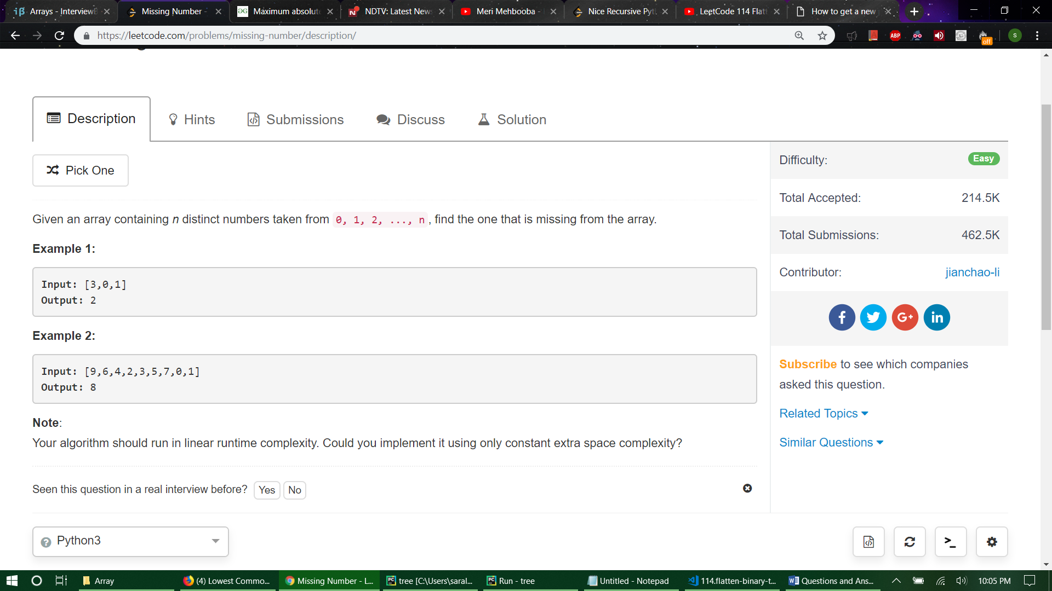

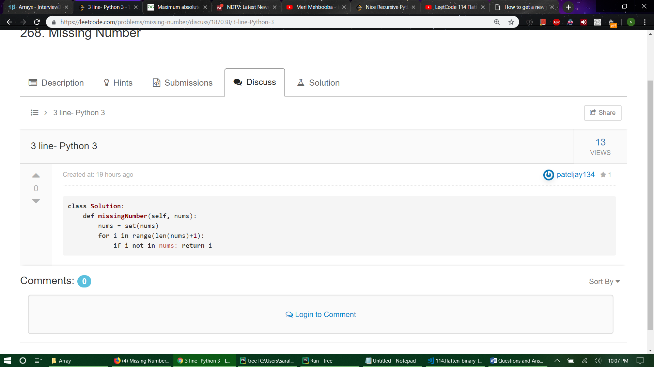

**def** **missingNumber**(self, nums):

"""

:type nums: List[int]

:rtype: int

"""

**if** **not** nums:

**return** **None**

total = sum(nums)

n = len(nums)

n_sum = (n * (n+1))//2

**return** abs(n_sum-total)

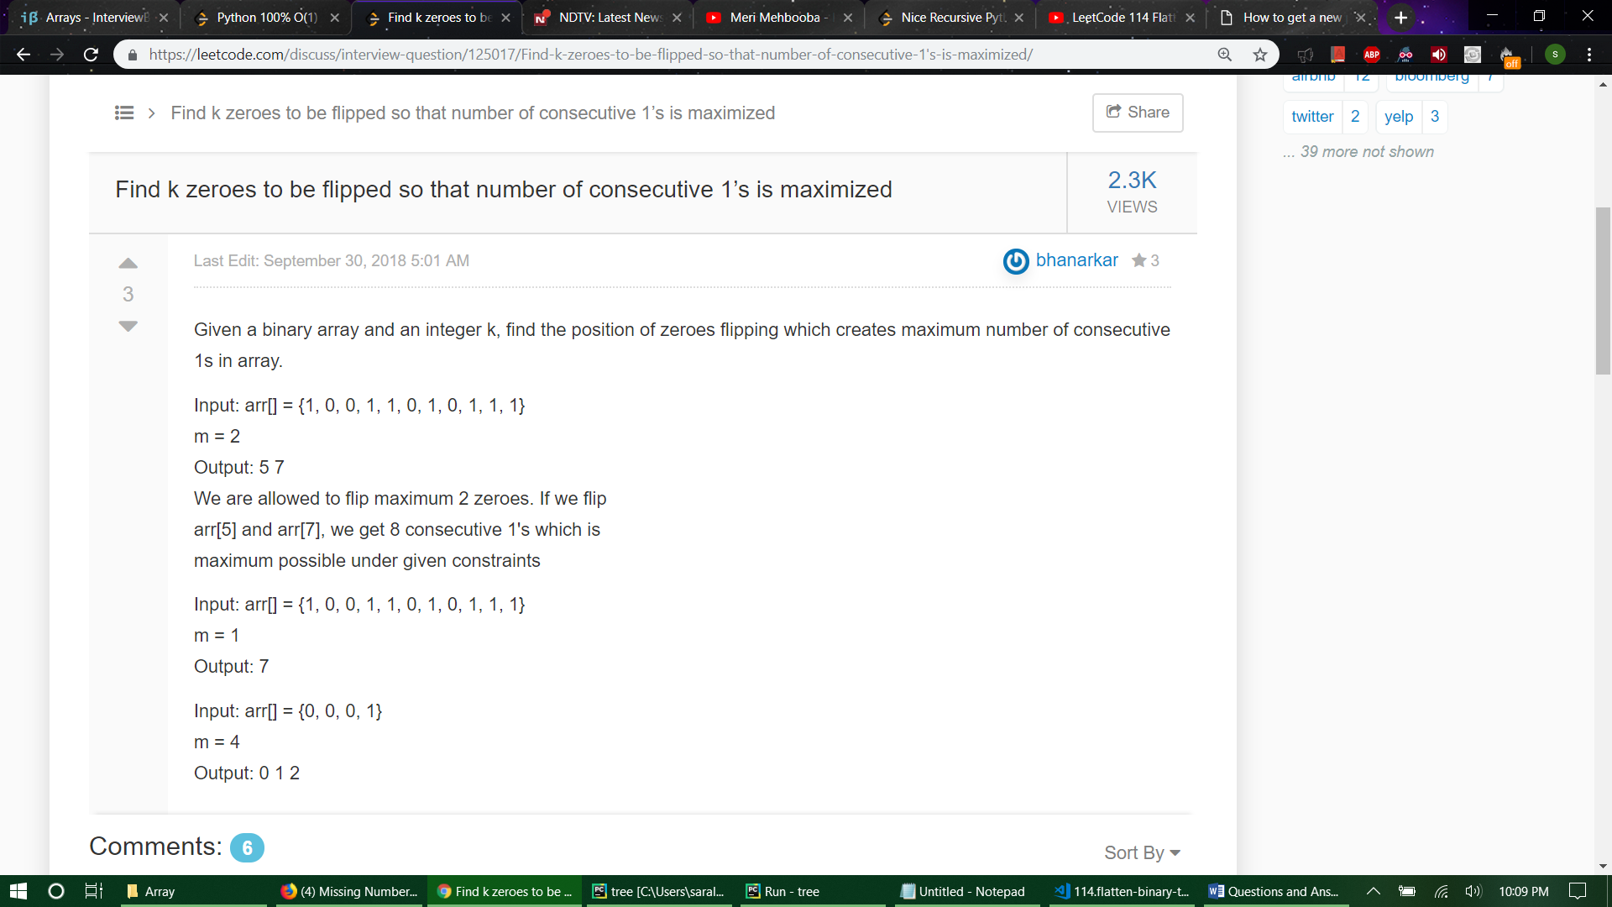

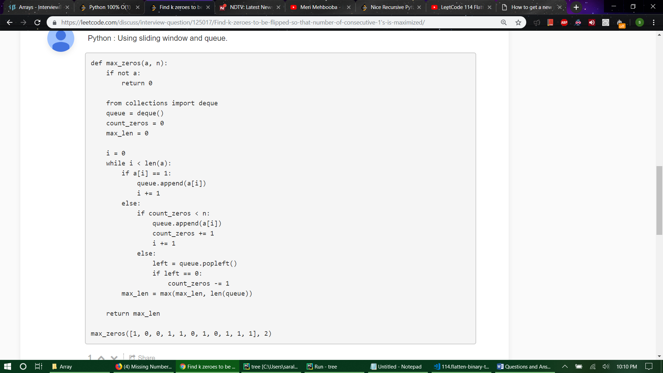

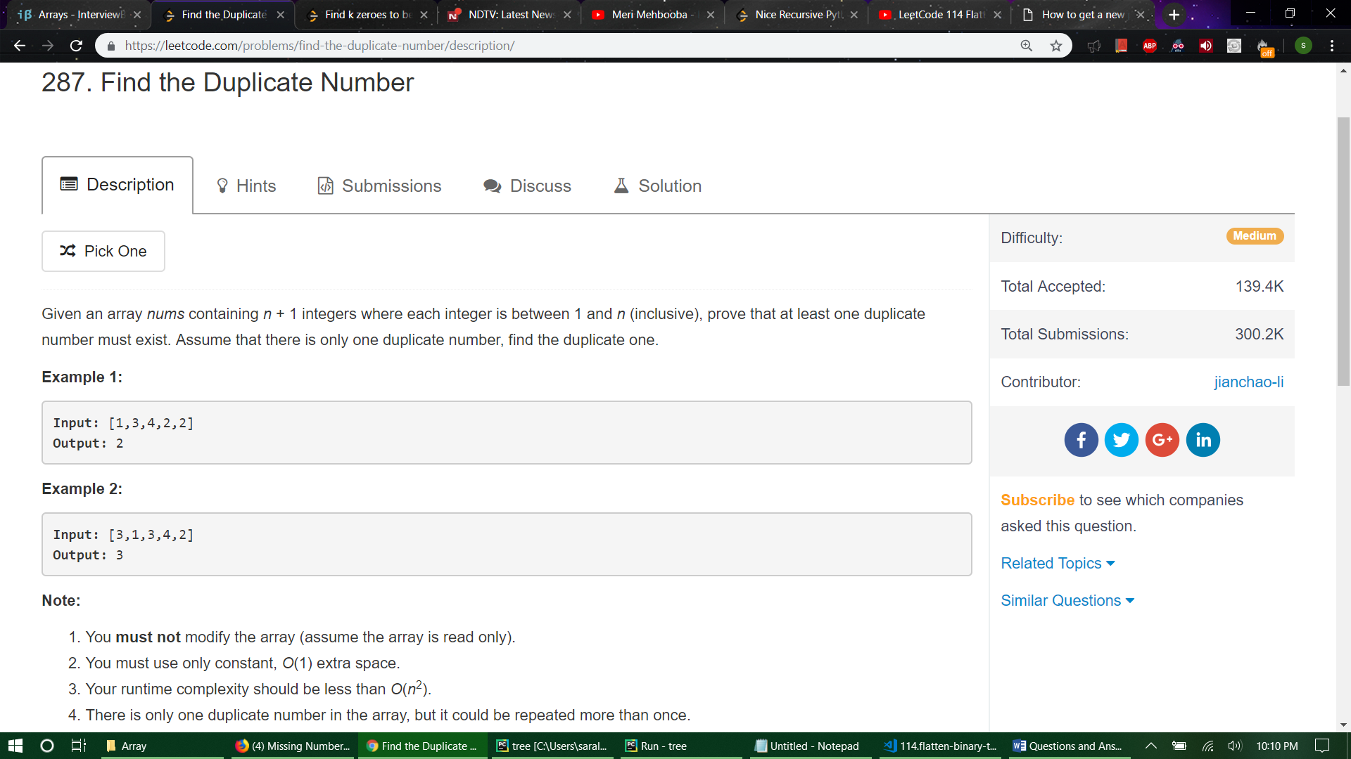

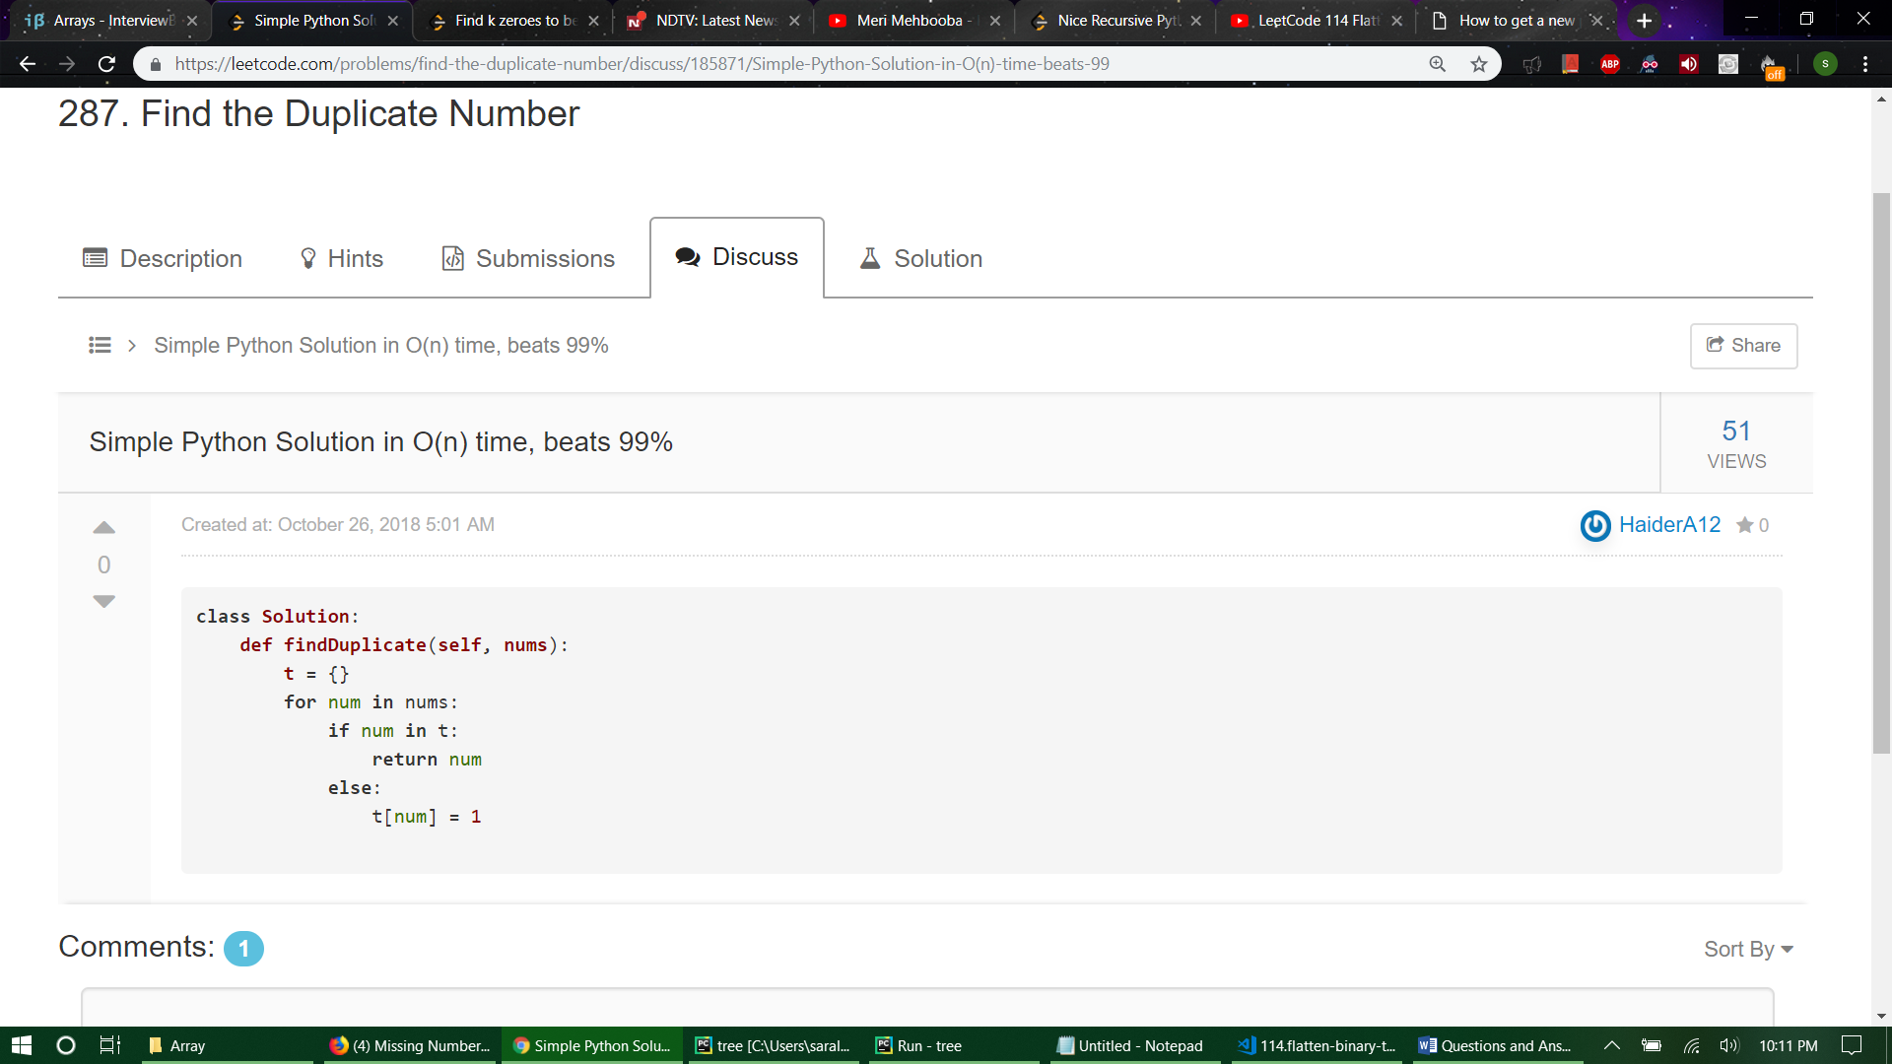

**class Solution:**

**def repeatedNumber(self, A):**

**a=list(A)**

**for i in range (len(a)):**

**ai=a[i]**

**temp=a[i]**

**temp=abs(temp)**

**if (a[temp]<0):**

**return(abs(a[i]))**

**a[temp]=-a[temp]**

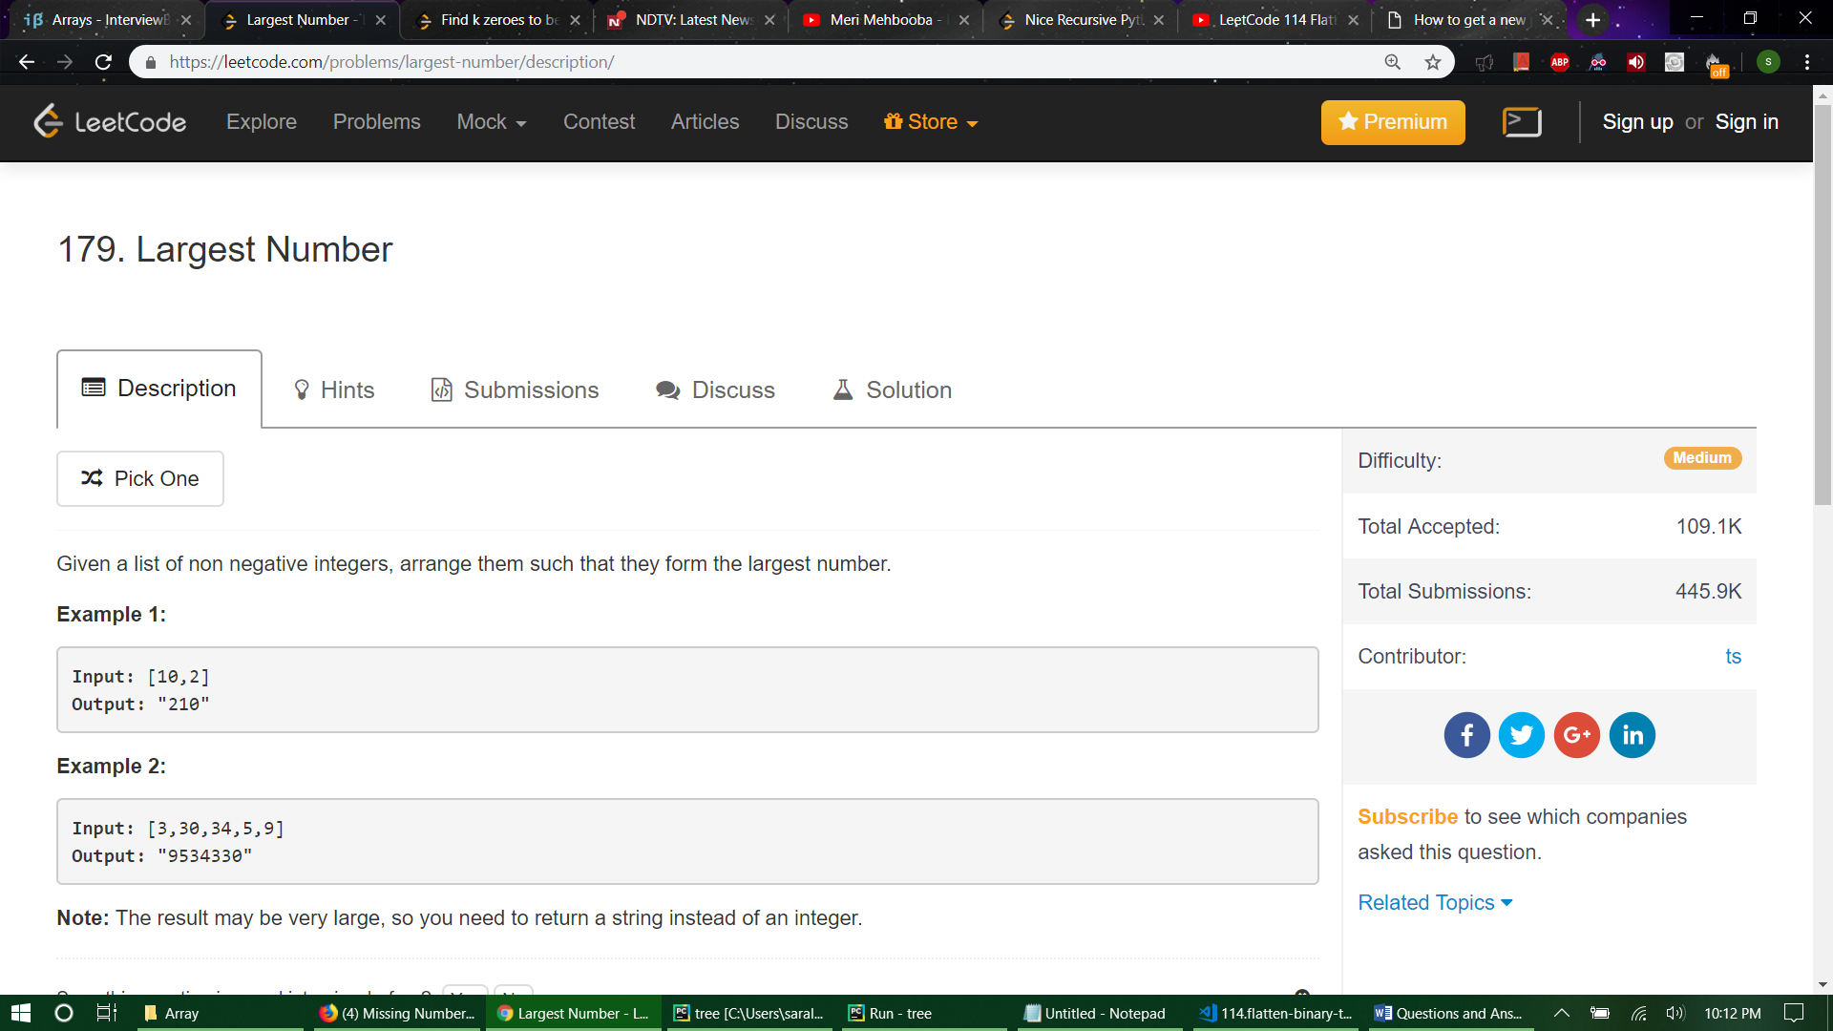

# build-**in** function

def largestNumber1(**self**, nums):

**if** not any(nums):

**return** "0"

**return** "".join(sorted(map(str, nums), cmp=lambda n1, n2: -1 **if** n1+n2>n2+n1 **else** (1 **if** n1+n2<n2+n1 **else** 0)))

# bubble sort

def largestNumber2(**self**, nums):

**for** i **in** xrange(len(nums), 0, -1):

**for** j **in** xrange(i-1):

**if** not **self**.compare(nums[j], nums[j+1]):

nums[j], nums[j+1] = nums[j+1], nums[j]

**return** str(int("".join(map(str, nums))))

def compare(**self**, n1, n2):

**return** str(n1) + str(n2) > str(n2) + str(n1)

# selection sort

def largestNumber3(**self**, nums):

**for** i **in** xrange(len(nums), 0, -1):

tmp = 0

**for** j **in** xrange(i):

**if** not **self**.compare(nums[j], nums[tmp]):

tmp = j

nums[tmp], nums[i-1] = nums[i-1], nums[tmp]

**return** str(int("".join(map(str, nums))))

# insertion sort

def largestNumber4(**self**, nums):

**for** i **in** xrange(len(nums)):

pos, cur = i, nums[i]

**while** pos > 0 and not **self**.compare(nums[pos-1], cur):

nums[pos] = nums[pos-1] # move one-step forward

pos -= 1

nums[pos] = cur

**return** str(int("".join(map(str, nums))))

# merge sort

def largestNumber5(**self**, nums):

nums = **self**.mergeSort(nums, 0, len(nums)-1)

**return** str(int("".join(map(str, nums))))

def mergeSort(**self**, nums, l, r):

**if** l > r:

**return**

**if** l == r:

**return** [nums[l]]

mid = l + (r-l)//2

**left** = **self**.mergeSort(nums, l, mid)

**right** = **self**.mergeSort(nums, mid+1, r)

**return** **self**.merge(**left**, **right**)

def merge(**self**, l1, l2):

res, i, j = [], 0, 0

**while** i < len(l1) and j < len(l2):

**if** not **self**.compare(l1[i], l2[j]):

res.append(l2[j])

j += 1

**else**:

res.append(l1[i])

i += 1

res.extend(l1[i:] or l2[j:])

**return** res

# quick sort, **in**-place

def largestNumber(**self**, nums):

**self**.quickSort(nums, 0, len(nums)-1)

**return** str(int("".join(map(str, nums))))

def quickSort(**self**, nums, l, r):

**if** l >= r:

**return**

pos = **self**.partition(nums, l, r)

**self**.quickSort(nums, l, pos-1)

**self**.quickSort(nums, pos+1, r)

def partition(**self**, nums, l, r):

low = l

**while** l < r:

**if** **self**.compare(nums[l], nums[r]):

nums[l], nums[low] = nums[low], nums[l]

low += 1

l += 1

nums[low], nums[r] = nums[r], nums[low]

**return** low

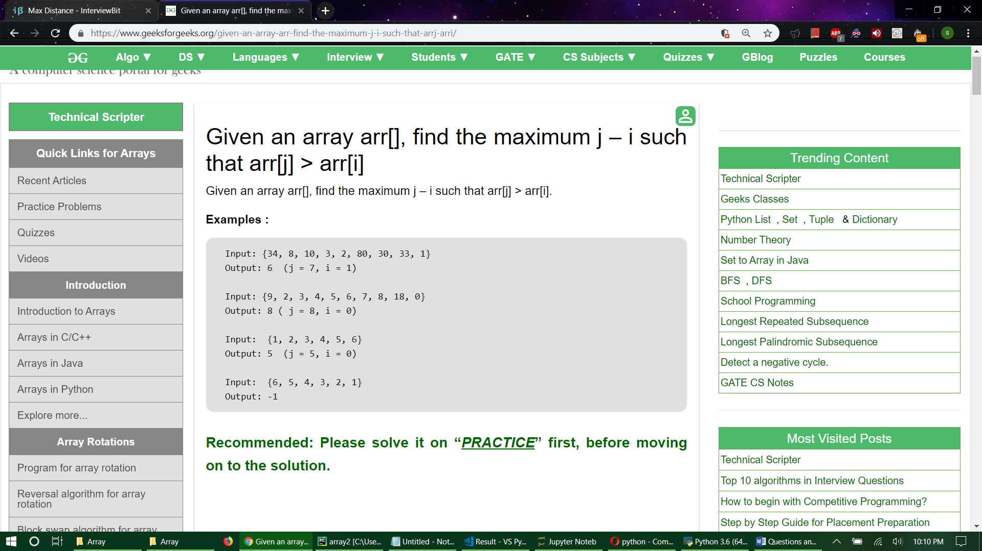

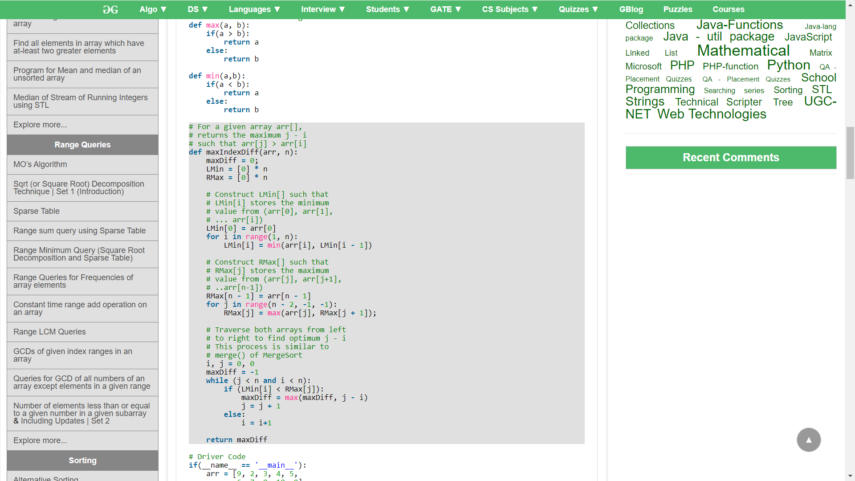

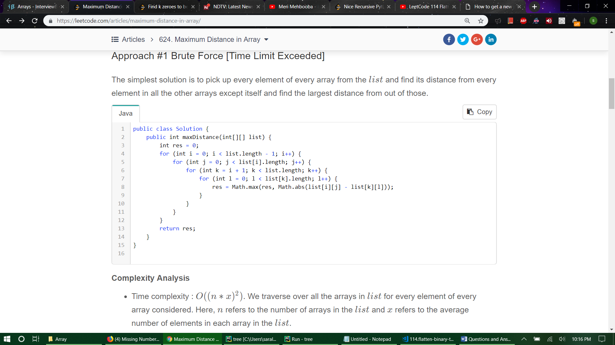

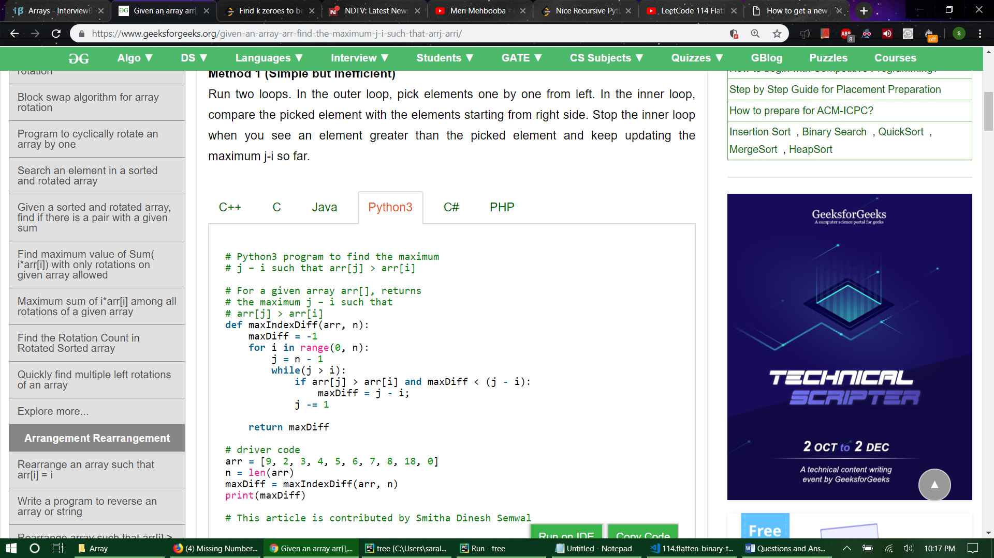

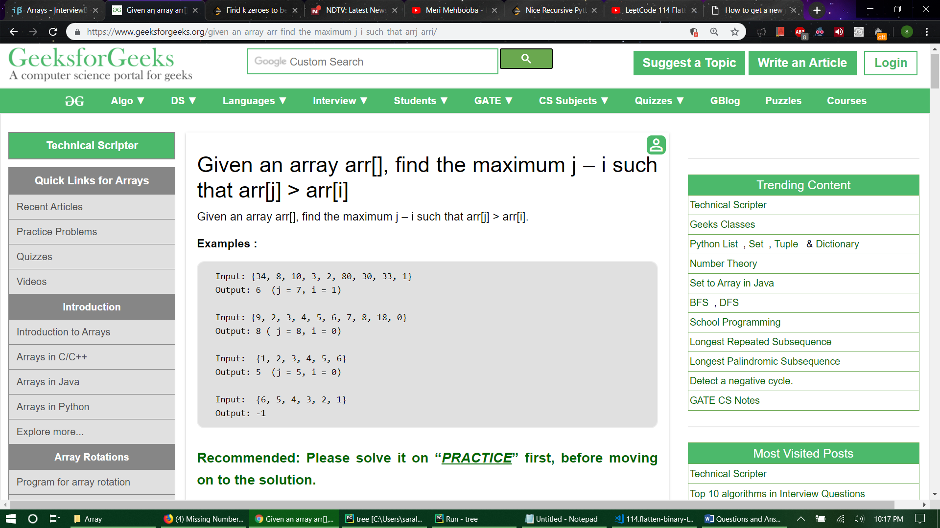

**This is end of 2 page question**

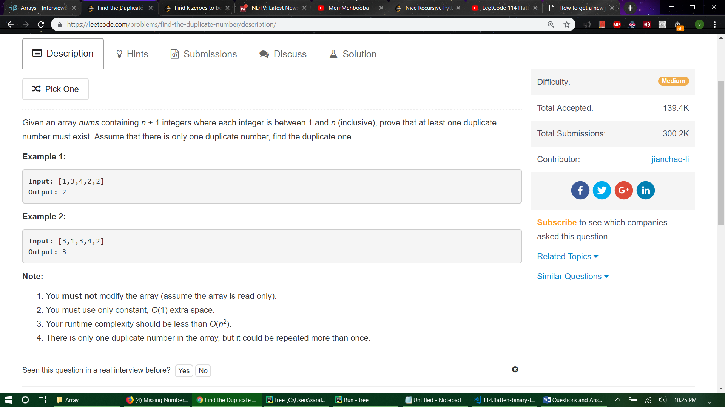

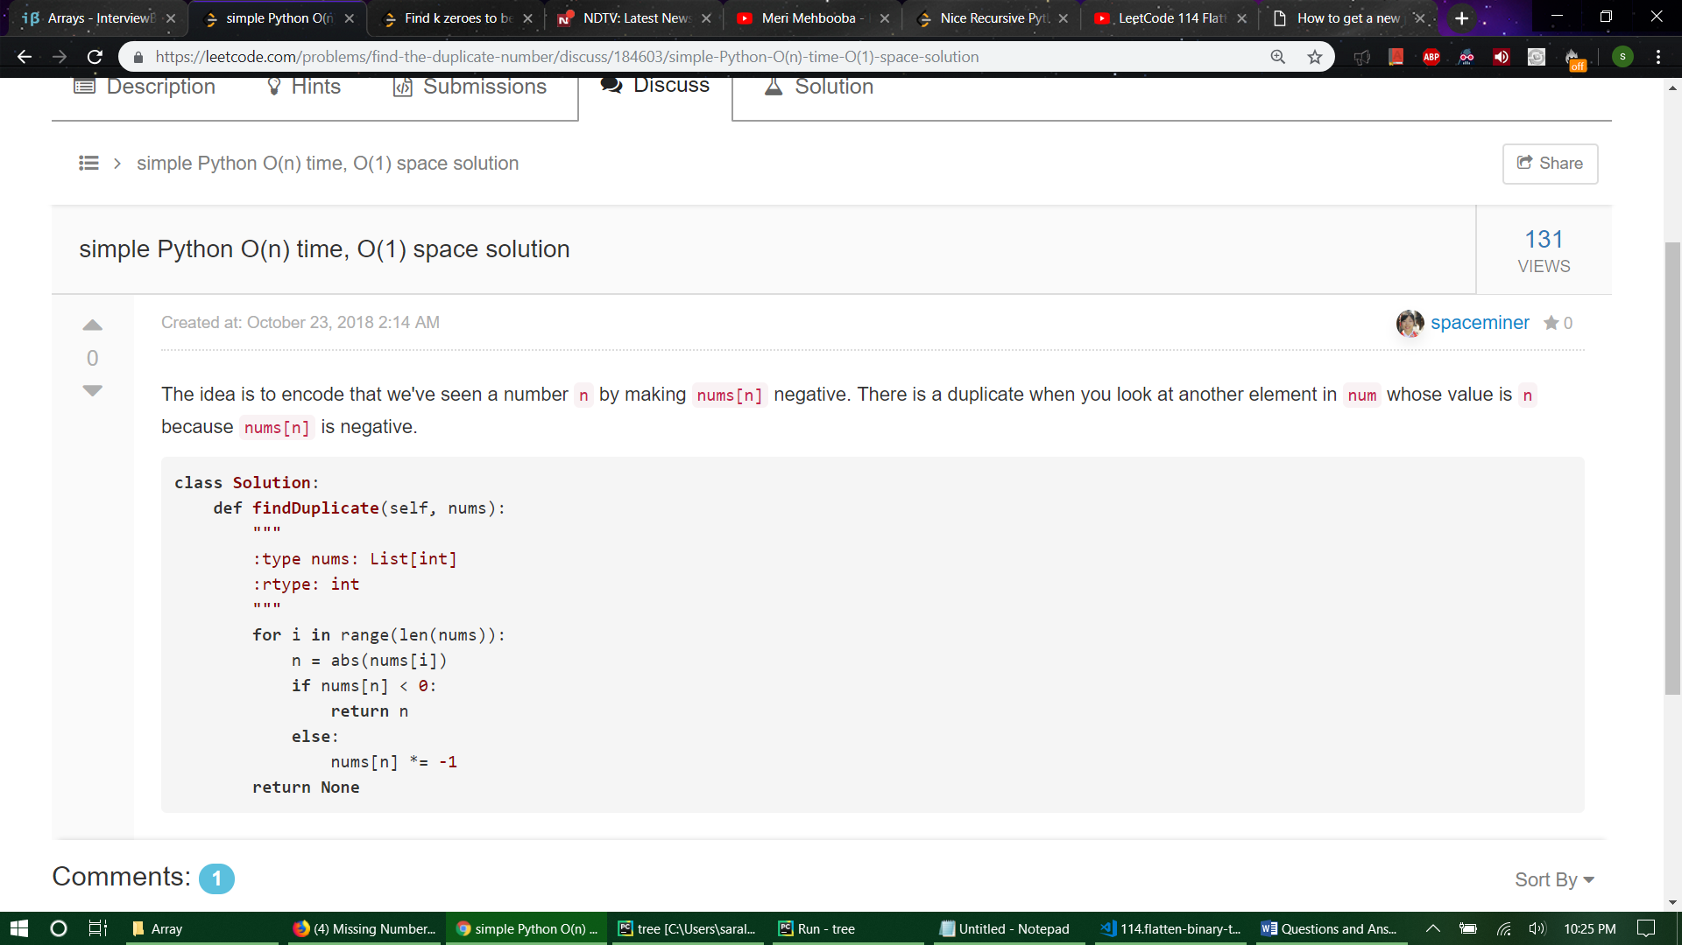

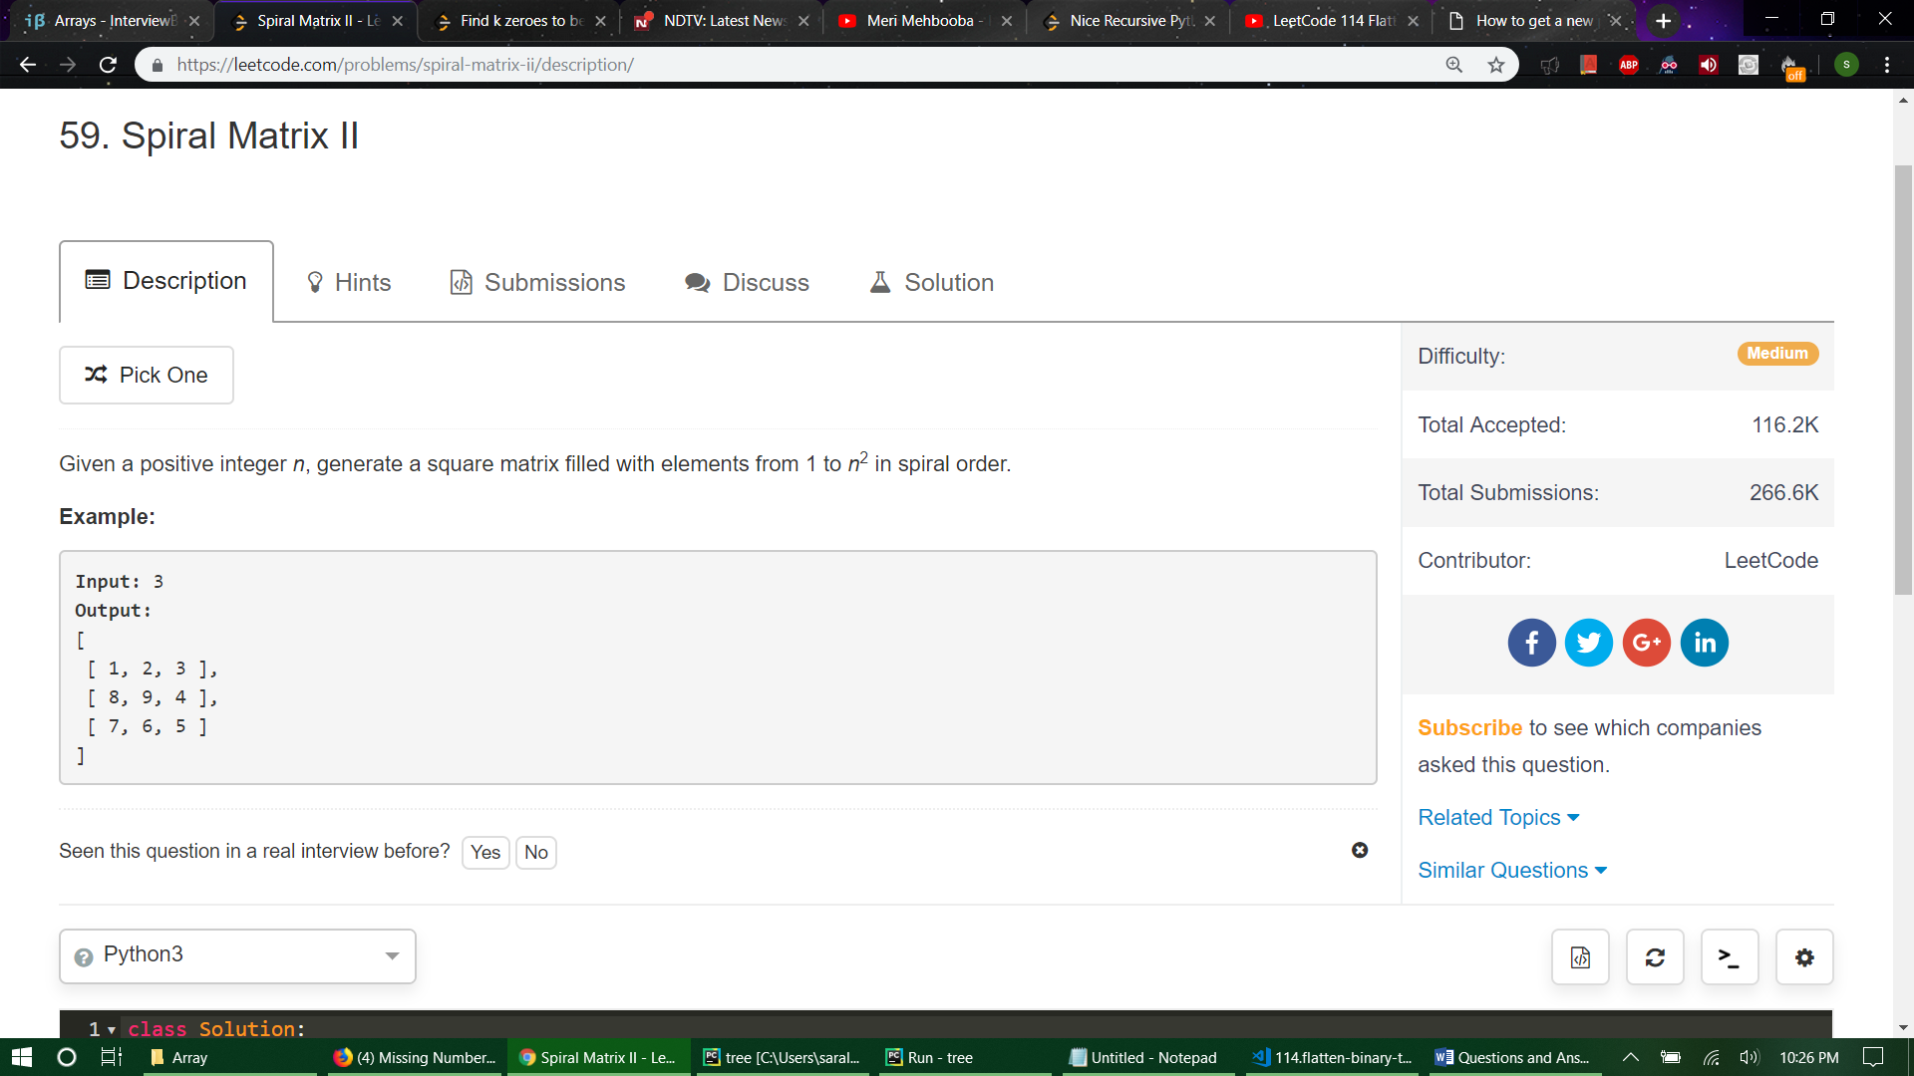

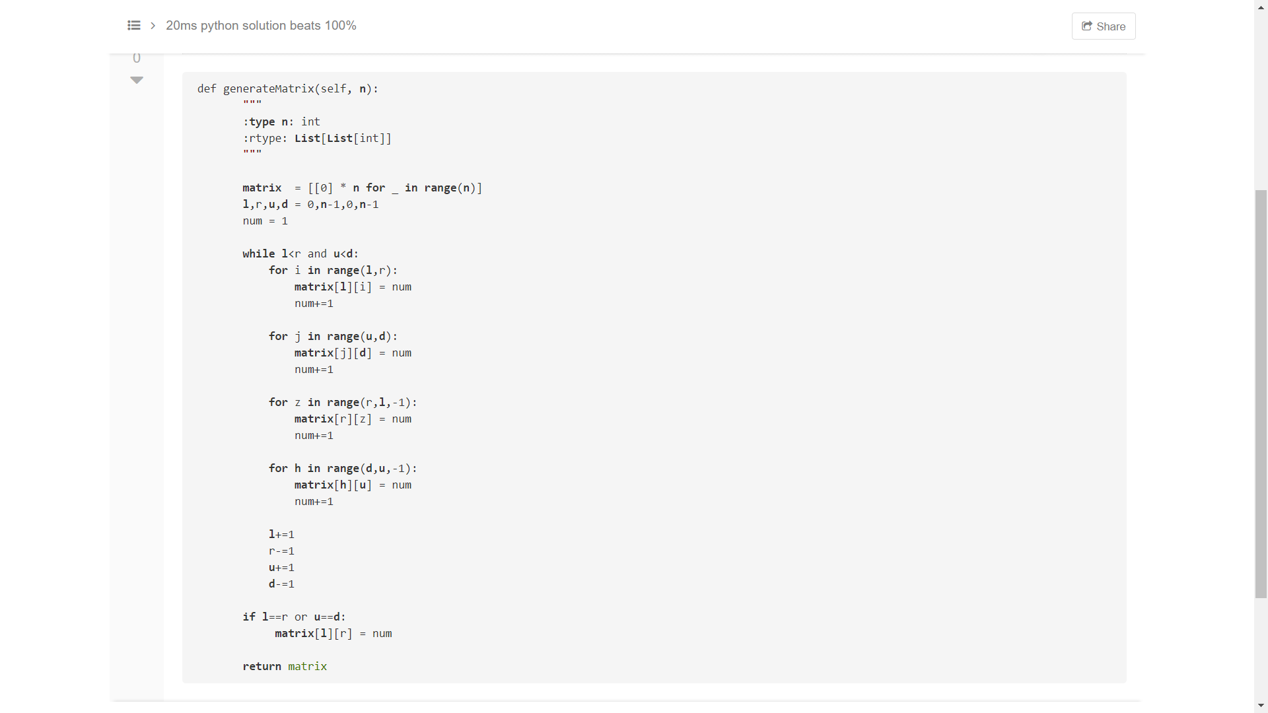

**class** Solution(object):

def generateMatrix(self, **n**):

"""

:**type** **n**: int

:rtype: **List**[**List**[int]]

"""

**if** **n**==0 : **return** ([[]])

**if** **n**==1 : **return** ([[1]])

tmp, ctr, **matrix** =1, 0, [[0 **for** j **in** **range**(**n**)] **for** i **in** **range**(**n**)]

**while** tmp < **n**\***n**:

**for** j **in** **range**(ctr, **n**-ctr-1): **matrix**[ctr][j] = tmp; tmp+=1

**for** i **in** **range**(ctr, **n**-ctr-1): **matrix**[i][-(ctr+1)] = tmp; tmp+=1

**for** j **in** **range**(ctr+1, **n**-ctr)[::-1]: **matrix**[-(ctr+1)][j] = tmp; tmp+=1

**for** i **in** **range**(ctr+1, **n**-ctr)[::-1]: **matrix**[i][ctr] = tmp; tmp+=1

ctr += 1

**if** **n**\***n**-tmp==0:

**matrix**[ctr][ctr]=**n**\***n**

**return** matrix

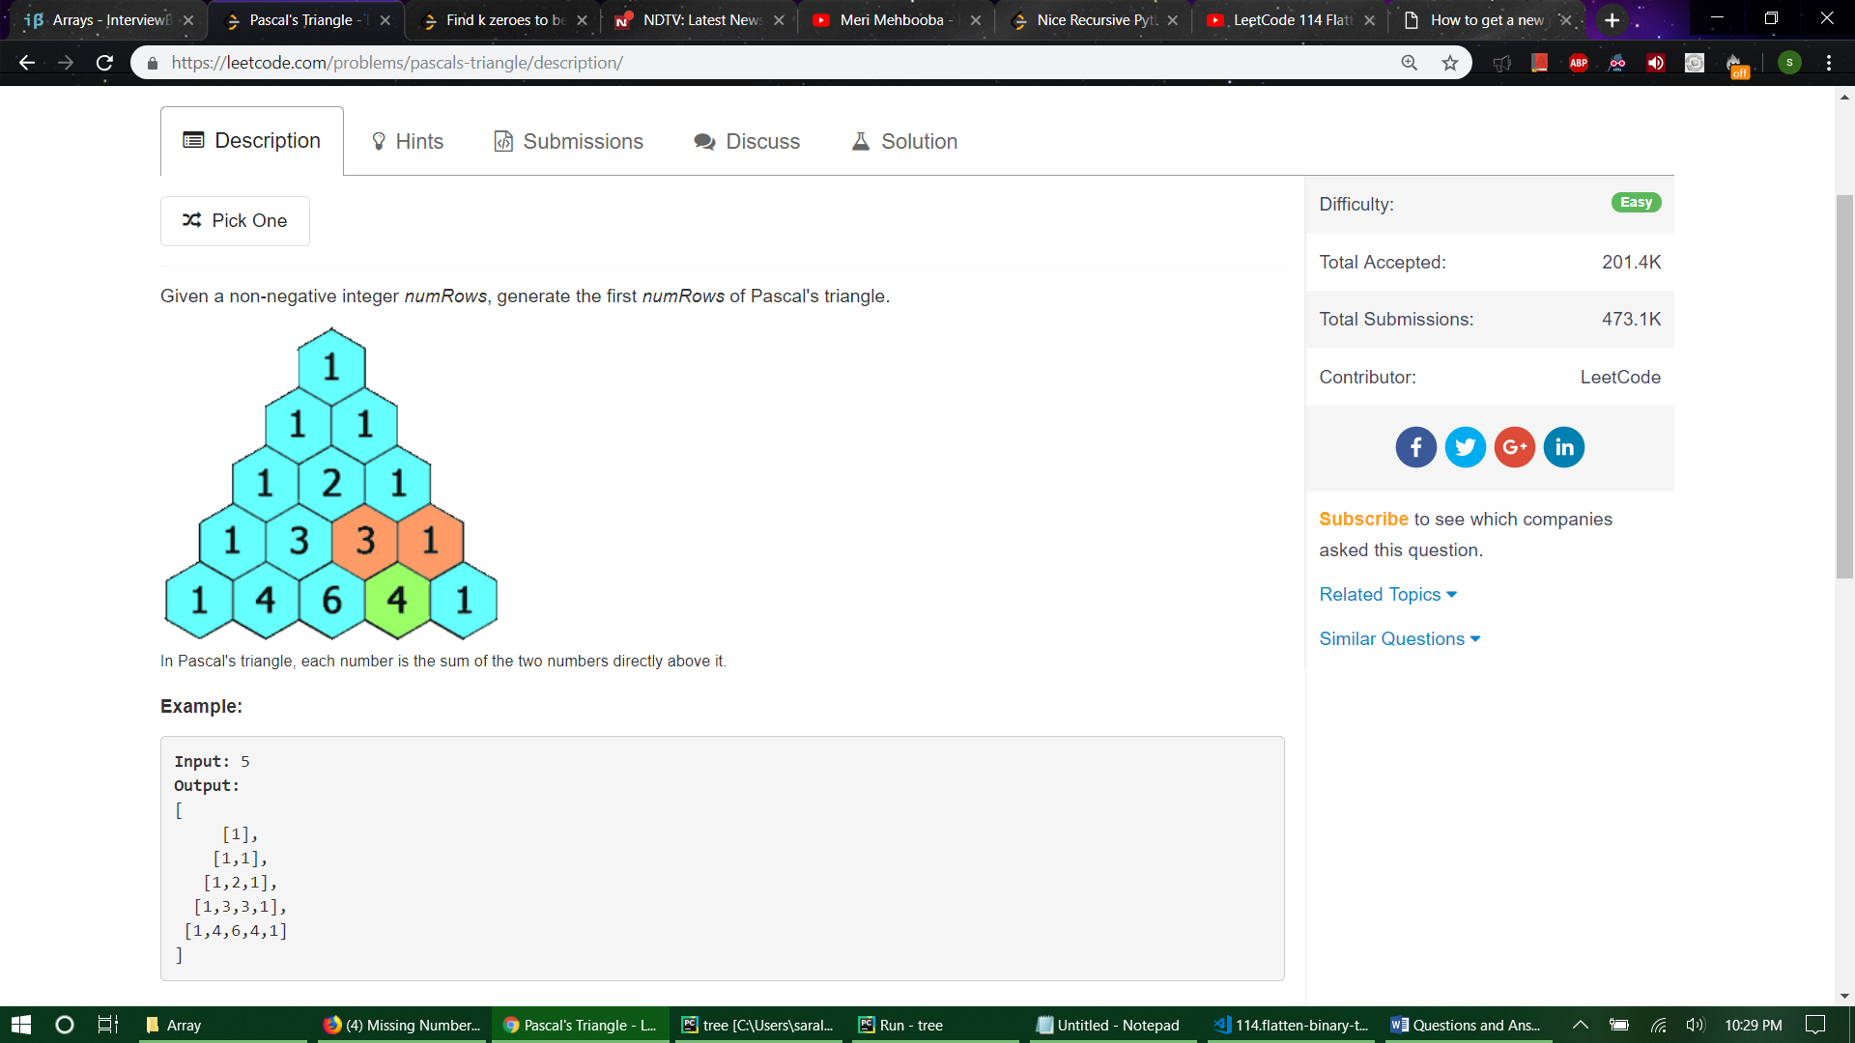

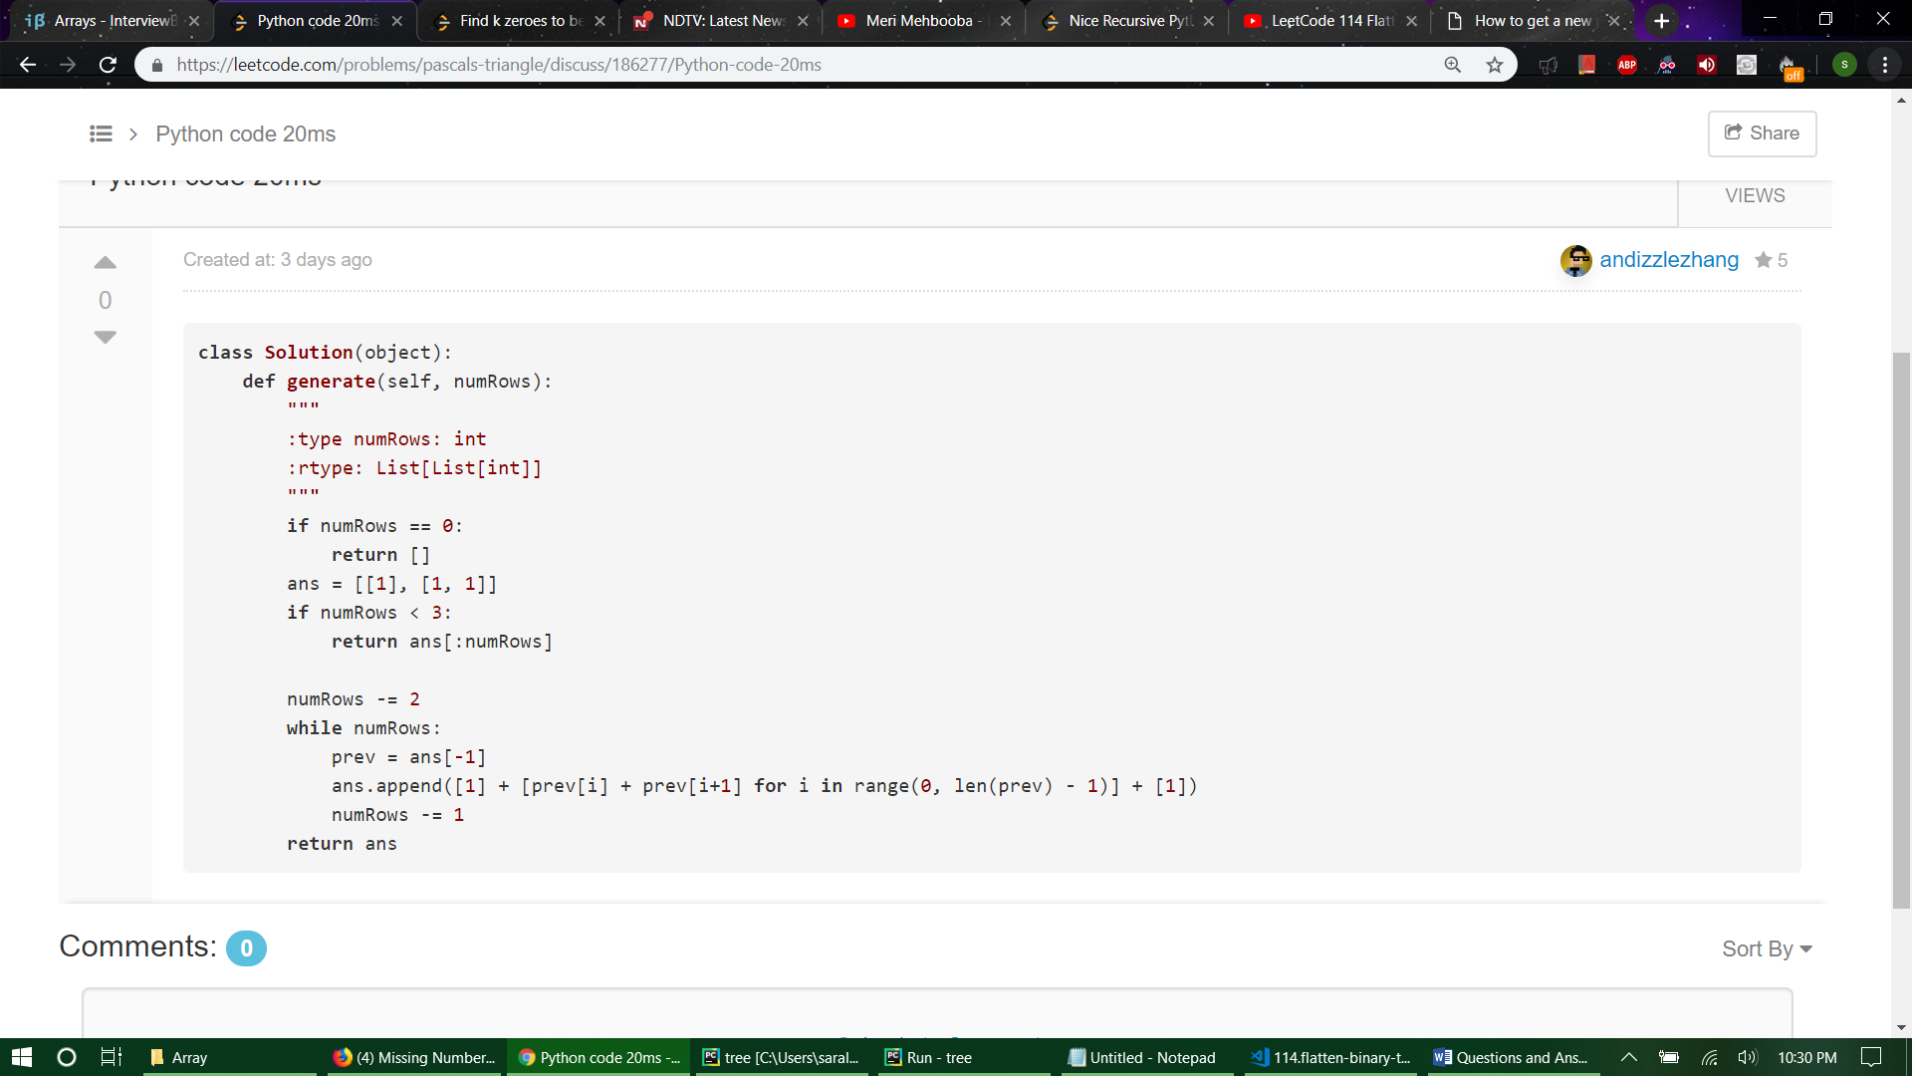

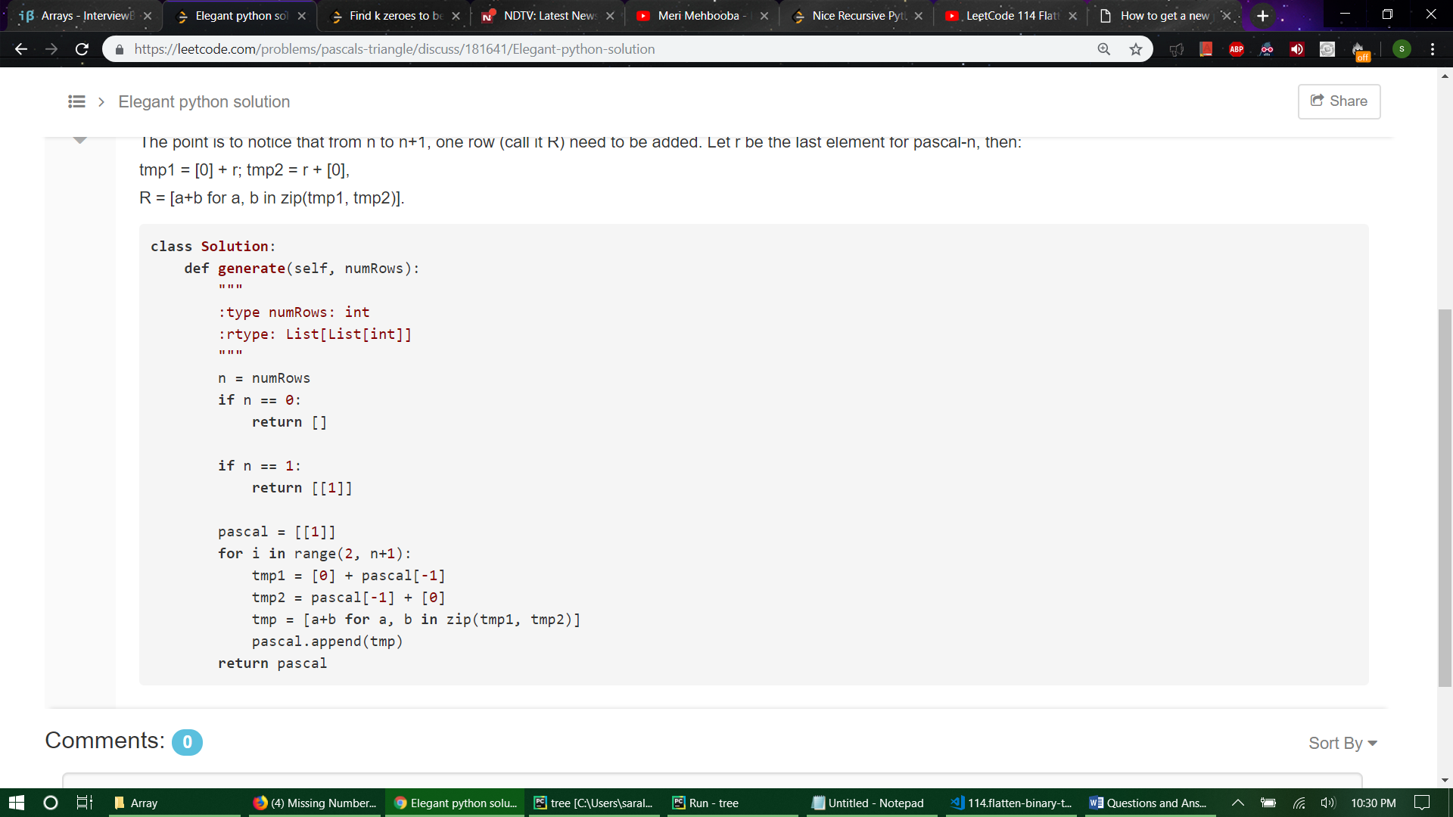

def generate(numRows):

pascal = [[1]*(i+1) **for** i in range(numRows)]

**for** i in range(numRows):

**for** j in range(1,i):

pascal[i][j] = pascal[i-1][j-1] + pascal[i-1][j]

**return** pascal

